Endangered Folk Arts Of India, Exhibition
Dakshinachitra Heritage Museum
Address: East Coast Road I Muthukadu I Chennai I India
4th - 19th January 2023

I, ____[ ENTER YOUR NAME HERE] age _______ [ ENTER YOUR AGE HERE]
residing in ____[ENTER YOUR ADDRESS HERE___ ],
email ____[ENTER YOUR EMAIL HERE]___ and mobile ___[ENTER YOUR MOBILE NUMBER HERE]
Hereby confirm the following artwork submitted for Endangered Folk Arts Of India as per International Indian Folk Art Gallery (IIFAG) Australia exhibition guidelines is my own creation and not copied work.
- Artwork # 1 – Title of the artwork
- Artwork # 2 – Title of the artwork
- Artwork # 3 – Title of the artwork
- Artwork # 4 – Title of the artwork
- Artwork # 5 – Title of the artwork

Planning to attend the event in person: YES / NO

Artist Name: Date & Signature

Details for Artwork # 1
- Image file name (example: DSC_2900 etc.,)
- Title of the artwork (example: Ramayana Story)
- Name of the Folk Art (example: Pattachitra Painting)
- Folk Art category (see below) (example: Indian Folk Art – Eastern region)
- Size of the artwork (example: 24 inches x 48 inches)
- With Frame? YES/NO
- Approximate weight in KG (example: 1 KG)
- Selling price (example: INR 20,000)
- Artwork Image [ Add your artwork image]

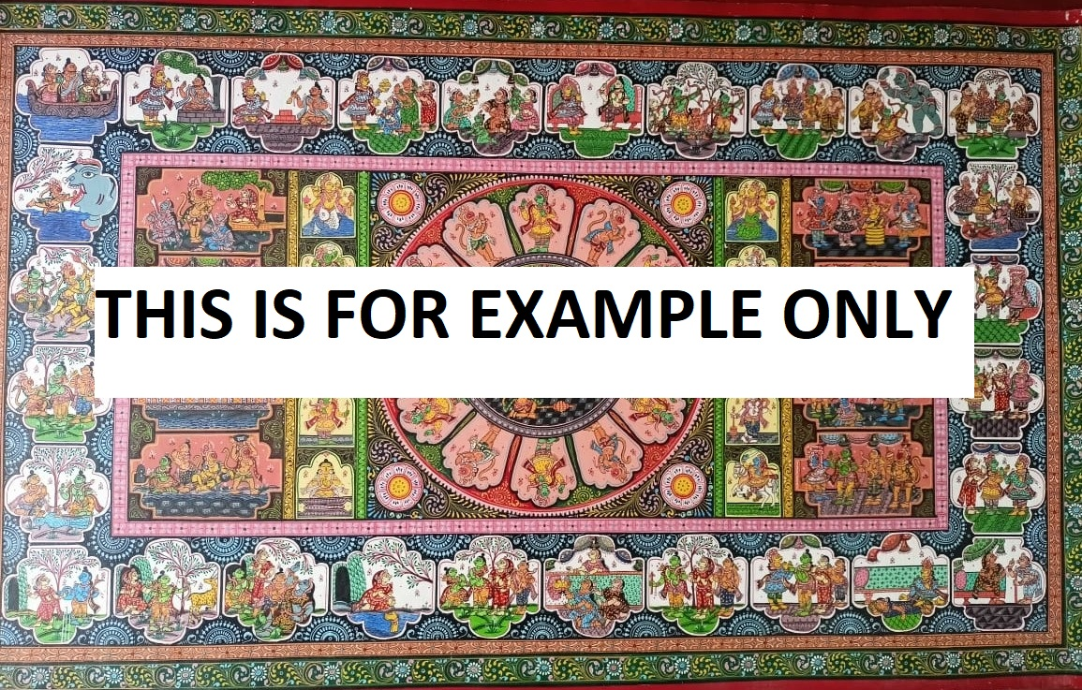

Artist Name: Date & Signature

Details for Artwork # 2
- Image file name (example: DSC_2901 etc.,)
- Title of the artwork (example: Ramayana Story)
- Name of the Folk Art (example: Pattachitra Painting)
- Folk Art category (see below) (example: Indian Folk Art – Eastern region)
- Size of the artwork (example: 24 inches x 48 inches)
- With Frame? YES/NO
- Approximate weight in KG (example: 1 KG)
- Selling price (example: INR 20,000)
- Artwork Image [ Add your artwork image]

Artist Name: Date & Signature

Details for Artwork # 3
- Image file name (example: DSC_2902 etc.,)
- Title of the artwork (example: Ramayana Story)
- Name of the Folk Art (example: Pattachitra Painting)
- Folk Art category (see below) (example: Indian Folk Art – Eastern region)
- Size of the artwork (example: 24 inches x 48 inches)
- With Frame? YES/NO
- Approximate weight in KG (example: 1 KG)
- Selling price (example: INR 20,000)
- Artwork Image [ Add your artwork image]

Artist Name: Date & Signature

Details for Artwork # 4
- Image file name (example: DSC_2901 etc.,)
- Title of the artwork (example: Ramayana Story)
- Name of the Folk Art (example: Pattachitra Painting)
- Folk Art category (see below) (example: Indian Folk Art – Eastern region)
- Size of the artwork (example: 24 inches x 48 inches)
- With Frame? YES/NO
- Approximate weight in KG (example: 1 KG)
- Selling price (example: INR 20,000)
- Artwork Image [ Add your artwork image]

Artist Name: Date & Signature

Details for Artwork # 4
- Image file name (example: DSC_2901 etc.,)
- Title of the artwork (example: Ramayana Story)
- Name of the Folk Art (example: Pattachitra Painting)
- Folk Art category (see below) (example: Indian Folk Art – Eastern region)
- Size of the artwork (example: 24 inches x 48 inches)
- With Frame? YES/NO
- Approximate weight in KG (example: 1 KG)
- Selling price (example: INR 20,000)
- Artwork Image [ Add your artwork image]

Artist Name: Date & Signature

